Assignment 3.2 SQL Rossler Gian Karlo Boquiren

Part 1.

Update all the dog's nulled comments to "woff, woff, woff"

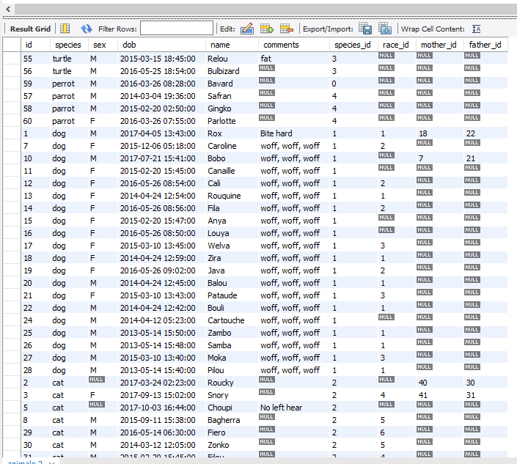

Part 2.

List of animals (Name, Sex, DOB, Race_Id) whose race description has the word color in it.  
  
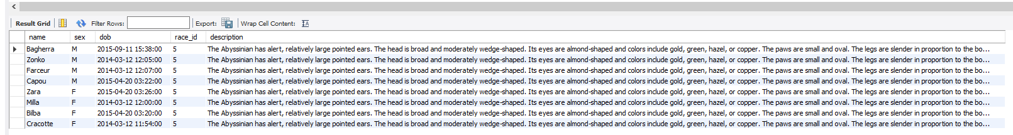

Part 3.

List of Bouli’s kid(s) (Name, Sex and DOB)

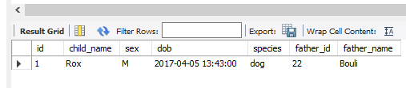

Part 4.

How many races exist in the animals table? (Display all of their names)

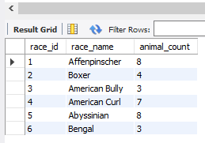

Part 5.

How many species exist in the races table? (Display all their names)

